Front End

Goals

- Minimalist. The over-riding goal is to reduce scope – spend our time on the game, not the front end.
- Get the user through it as quickly as possible.
- Within the constraints of the above goals, make it look great.
- Within the constraints of the above goals, make it simple for the User.
- Implement the Front End in the quickest way that will produce a high quality result

Controls
For all platforms, the start button will be used to enter a pause menu. While in a pause menu or in the front end, the following controls will be used:

Controller section
- Users must be able to start the game with any supported controller on any controller port. Once started, users must not be required to switch controllers or controller ports to play the game. The controller plugged into slot 1 will always be player 1 and the controller plugged into slot 2 will always be player 2, 3 = 3, and 4 = 4.
- Multiplayer will only support 2 players, but any two of the four controllers will work
Loss of Controller
- Within one second of the loss of an in-use controller, the game must suspend the game in progress if such a feature is supported (ie. Pause feature).

Playstation 2
- X will be used to advance or make a selection
- Δ will be used to go back to previous screen
- The directional pad will be used for navigation

Xbox
- A button must select the current option, confirm action, invoke the selected action, or move to the next menu.
- B button and the BACK button must cancel an action, dismiss a menu, or return to the previous menu.
- START button may be mapped to the same functionality as the A button, or it may perform a more appropriate action (such as quick-starting or leaving pause states).
- The directional pad must be usable for navigation

Gamecube
- A button must select the current option, confirm action, invoke the selected action, or move to the next menu.
- B button must cancel an action, dismiss a menu, or return to the previous menu.
- The control stick and control pad will be used for navigation

Features

Front-end menu (main menu)
- The front end menu will be a 3D image of the Simpsons’ living room
- Special effects for selection
  - Items in the room will indicate selection
  - Text will also be provided to provide clarity
- The only functional requirements of the FE is the ability to choose game type or set session settings:
  - Continue latest saved game – Continue latest saved game will only be accessible if, during the boot-up process, a previous game has been detected and there is sufficient space. If these qualities are met, that game will be auto-loaded on start-up and you will proceed from the latest save location of the most recent game.
  - New Game – will take you straight to game play starting at the beginning of the game.
  - Load game – The Memory card/Hard Drive will be divided into 8 Slots allowing for 8 possible different games to be saved. Games will be saved according to the following naming convention:
- Date
- Time
- Level
- Mission
Once a selection is chosen, the user will be taken back to the main menu. From there, the default value will be resume game which will take them directly to the game, commencing from the location they just loaded.
  - Card Gallery – goes to the card gallery to view collector cards associated with the auto-loaded game.
  - Multiplayer – The multiplayer front-end will try to get the players to the game as quick as possible. Upon selection, the Users will be taken to the Multiplayer Setup Screen.
    - Different home bases
- Lard Lad donuts
- Police station
- Moe’s
    - Number of points they would like to play to.
From there you go to the:
Choose vehicle screen
    - The important element of this screen is to show the vehicle ratings – i.e., so that both users can pick a “fast” vehicle if they want
      - Character thumbnails (with a visual cursor for selection – color coded for players 1 and 2)
      - Car Statistics
      - Speed (Hoarse power)
      - Turning ability
      - Weight (Durability)
      - Car Picture (static)
  - Options - The options screen is minimalist – it will be presented like the pause screen, with simple text menus.
- Controls Configuration – allows the user to decide between two predetermined controller configurations (separate screen). Similar to last year.
- View Movies (separate screen)
- Game Credits (separate screen). Similar to last year
- Vibration On/Off (Toggle)

In-Game Menus (pause menus)
- In-game menus will be 2D
- Special effects for FE screens and Pause menu:
  - Flashing text to indicate highlighted object (see Smuggler’s Run 2 for a good example)
  - Sounds
  - Music
- The pause menu will show different items depending on whether the user is in Sunday Drive Mode or Mission Mode.
- Pause menus will be activated by pressing the start button and will be exited by backing out (appropriate button) or by pressing start again.

Sunday Drive Pause Menu
  - Save Game - lead you to a different screen allowing the user to save the game to the memory card and/or hard disk.
    - TRC concerns
    - Save menu contains eight slots for User games
      - Default to latest or loaded game
      - Games are identified by Date, Level, Mission (Not User defined)
  - View Map – a larger version of the Level Map
  - Card Gallery – takes you to the Card Gallery where all collector cars that have been found are shown and those that are yet to be found are shown as a question mark
  - Mission Select - allow a user to go back and play any mission that they have previously passed on the loaded game – will likely cause a game/world load.
    - If you go back to an earlier mission, we need to “clear out” memory of which save file the current user is using, so that it does not get over-written unless the user explicitly says so
  - Settings – separate screen
    - Vibration on/off
    - Controller Configuration – same as Road Rage
    - Sound Settings – same as Road Rage
    - Camera Choice – same as Road Rage, but possibly without “Far” camera
  - Quit Game – If there has been progress in the game (i.e. missions passed or cards collected) then it will prompt whether or not you would like to save then return the user to the front end

Mission Mode Pause Menu
  - Restart Mission – Brings you back to the beginning of the mission
  - Abort Mission – Quits the current mission and returns you to Sunday Drive Mode at your current location
  - View Map – a larger version of the Level Map
  - Settings – separate screen
    - Vibration on/off
    - Controller Configuration – same as Road Rage
    - Sound Settings – same as Road Rage
    - Camera Choice – same as Road Rage, but possibly without “Far” camera
  - Quit Game – If there has been progress in the game (i.e. missions passed or cards collected) then it will prompt whether or not you would like to save then return the user to the front end

Multiplayer Pause Menu
  - View Map
  - Restart Head to Head – restart from beginning of mission
  - Settings – separate screen
    - Camera Choice – same as Road Rage, but possibly without “Far” camera
    - Controller Configuration
    - Sound Settings – same as Road Rage
    - Vibration on/off
  - Quit Game – return to main Front End

Memory Card Error Handling Process
All memory card error-handling messages will be presented in a simple 2D text box.

Flow

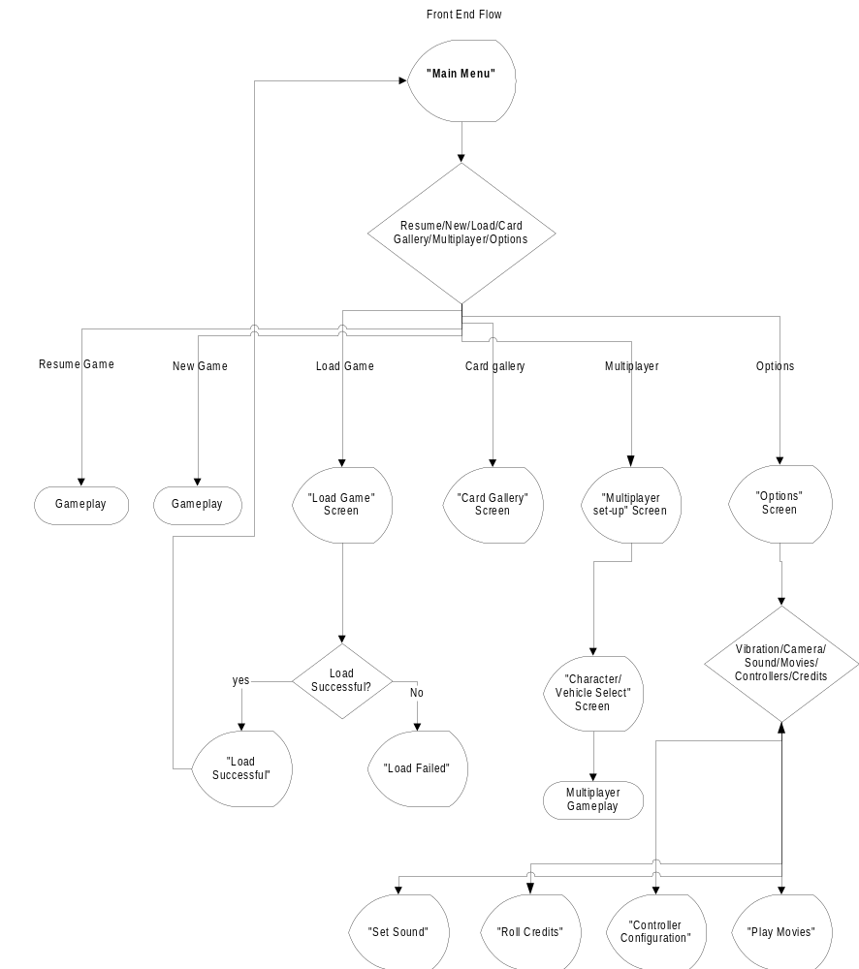

Menus

Generic
1. Generic Yes/No
2. Generic General Message (x=ok)

Memory Card
1. No memory card. proceed?
2. Memory card not formatted
3. Memory card Damaged
4. Memory card contains corrupt data
5. Not enough memory
6. Game requires nKB. Initialize?
- File successfully initialized
- Game successfully loaded
- Load failed
- Game successfully saved
- Save failed
- Loading…

Main Menu
1. Main Menu

Multiplayer
1. Multiplayer Set up
2. Multiplayer Choose Character

Options
1. Options
2. Controller configuration
- View Movies
- Game Credits
- Sound

Card Gallery
  - Cards per level
  - Individual Cards

Pause Menu (single player)
1. Pause Menu (single player)
- Mission Objectives
- Select Mission
4. Save Screen
5. Map
6. Select Mission
7. Sound Settings – same as Road Rage
8. Controller Configuration

Pause Menu (multiplayer player)
1. Pause Menu (multiplayer player)
2. Options
3. Sound Settings – same as Road Rage
4. Controller Configuration

Game Over
- Game Over (single player)
- Game Over (multiplayer)

Total = 38

